Emerald Downs Live Model Horse Show  March 23, 2024 |  | 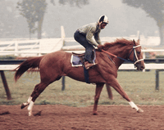

Show Hostess:  Debbie Connell  shecat87@comcast.net  253-508-3220 (cell)  Web Site: emeraldlivemhs.weebly.com  Show Divisions:  OF Stone – Judge Michelle Hansen  OF Plastic – Judge Elizabeth Wehnert  OF Mini – Judge Shannon Antipov  Artist Resin (all sizes) – Judge Amy McCudden  Custom (all sizes) – Judge Michelle Eisley  Collectibility (all sizes) – Judge Dawn Shaw  Performance (OF & AR/CM) – Judge Allison Mazurkiewicz  Entry Fee (for all divisions): $65  Extra and/or Sales Table: $50 | 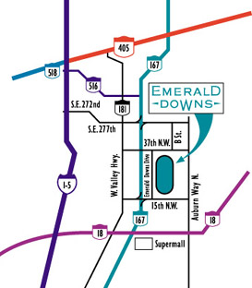
Awards:
Silk flats for 1st-5th place
Paper Certificates for Champion and Reserve Champion
Special Awards for Overall Division Champion and Reserve Champion
**NOTE** - We will be offering my favorite specialty class – all 3rd place finishing models will be eligible for a special class to be judged by the show holder. ONE entry per person, please!

Class Size Limit: TWO MODELS per entrant for ALL divisions. $1 buy-ins allowed, but please keep to a minimum!

This will be a NAN-qualifier show. All first and second place equids in eligible classes will receive a NAN card to attend the North American Nationals.

Raffles, Raffles, Raffles!
All entrants are encouraged to bring something for the raffle(s) in support of the show! There will be LOTS of great items available!! Tickets $1/each or 6 for $5.

Area Hotels
Comfort Inn Auburn  One 16th St NE  Auburn WA 98002  Reservations Direct: 253-263-7458 | Garner Auburn – An IHG Hotel  9 14th St NW  Auburn WA 98001  Reservations Direct: 253-735-9600 | Best Western Mtn View Inn  401 8th St SW  Auburn WA 98001  Reservations Direct: 253-887-7600

Emerald Downs Live Model Horse Show
March 23, 2024

Mail Entries to: | Debbie Connell  34926 28th Ave S  Federal Way WA 98003 | Personal checks, money orders and PayPal accepted (PayPal address: shecat87@comcast.net)  Web site: emeraldlivemhs.weebly.com

Name:
Address:
City, State, Zip:
Email:
Region 1 Tag #:

Entry Deadline: March 16, 2024

 | Fee | No. of entries | Total
Unlimited Entry | $65.00
Sale/Extra Table | $50.00
Late Entry Fee for Unlimited Entry (after 3/16/24) | $75.00
TOTAL FEES

Results (check one): | Please email to me |  | Will obtain from NAMHSA web page

I’d like my table near (I’ll do my best to accommodate, but no promises): ______________________________________________________________________________

I hereby release Debbie Connell, the event coordinators, judges, helpers for Emerald Downs Live, and all employees of Emerald Downs and/or Emerald Downs Racing LLC, as well as the facility management, of any liability for any personal injury, property damage or loss that may occur during the course of this event. I have read and understood the rules of Emerald Downs Live and agree to abide by these rules. I understand that if these rules are violated, I may be asked to leave the event at any time with no refund of fees.

Signature: |  | Date:
Parent/Guardian:

